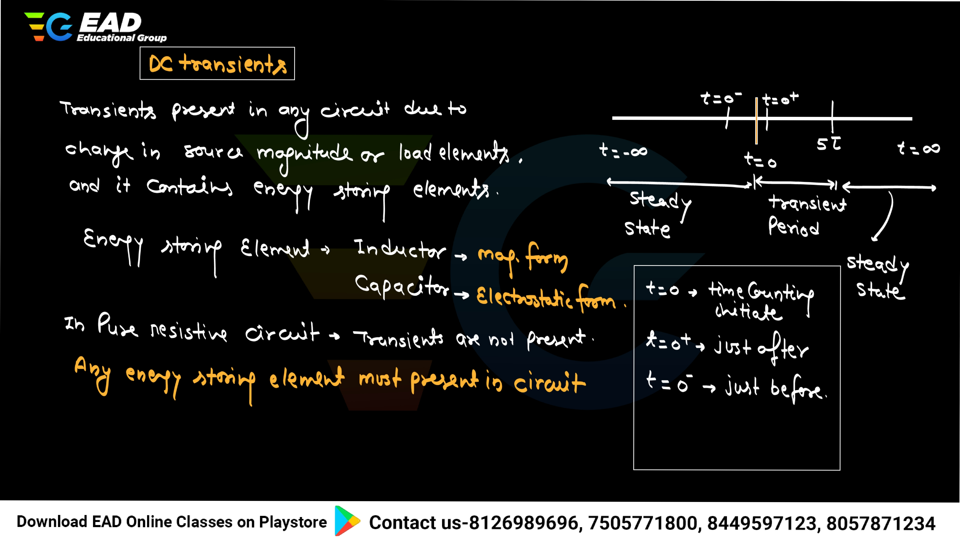

[LAKSHYA BATCH FOR ALL ELECTRICAL ASSISTANT ENGINEERING EXAMS | | Download EAD Online Classes app -> **click here**](https://eadonlineclasses.com/courses/435357?utm_source%3Dother%26utm_medium%3Dtutor-course-referral%26utm_campaign%3Dcourse-overview-webapp)

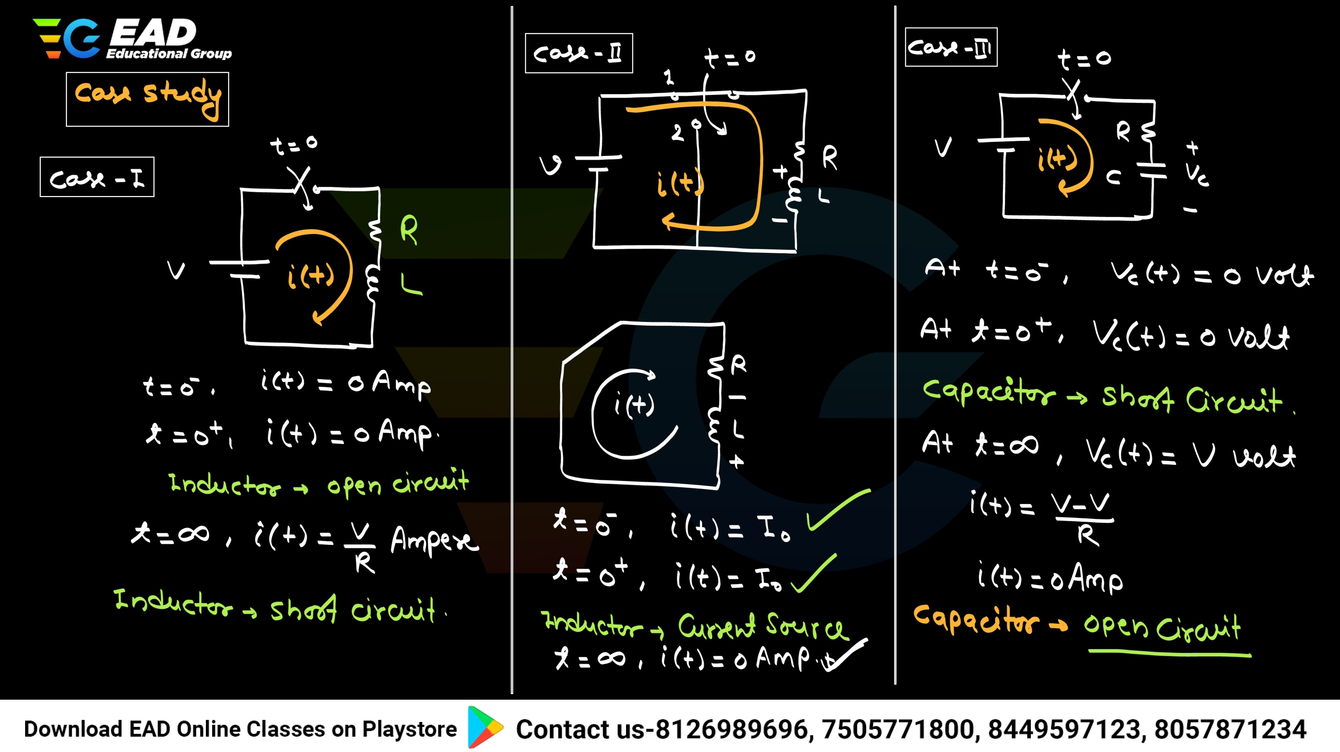

[LAKSHYA BATCH FOR ALL ELECTRICAL ASSISTANT ENGINEERING EXAMS | | Download EAD Online Classes app -> **click here**](https://eadonlineclasses.com/courses/435357?utm_source%3Dother%26utm_medium%3Dtutor-course-referral%26utm_campaign%3Dcourse-overview-webapp)

app

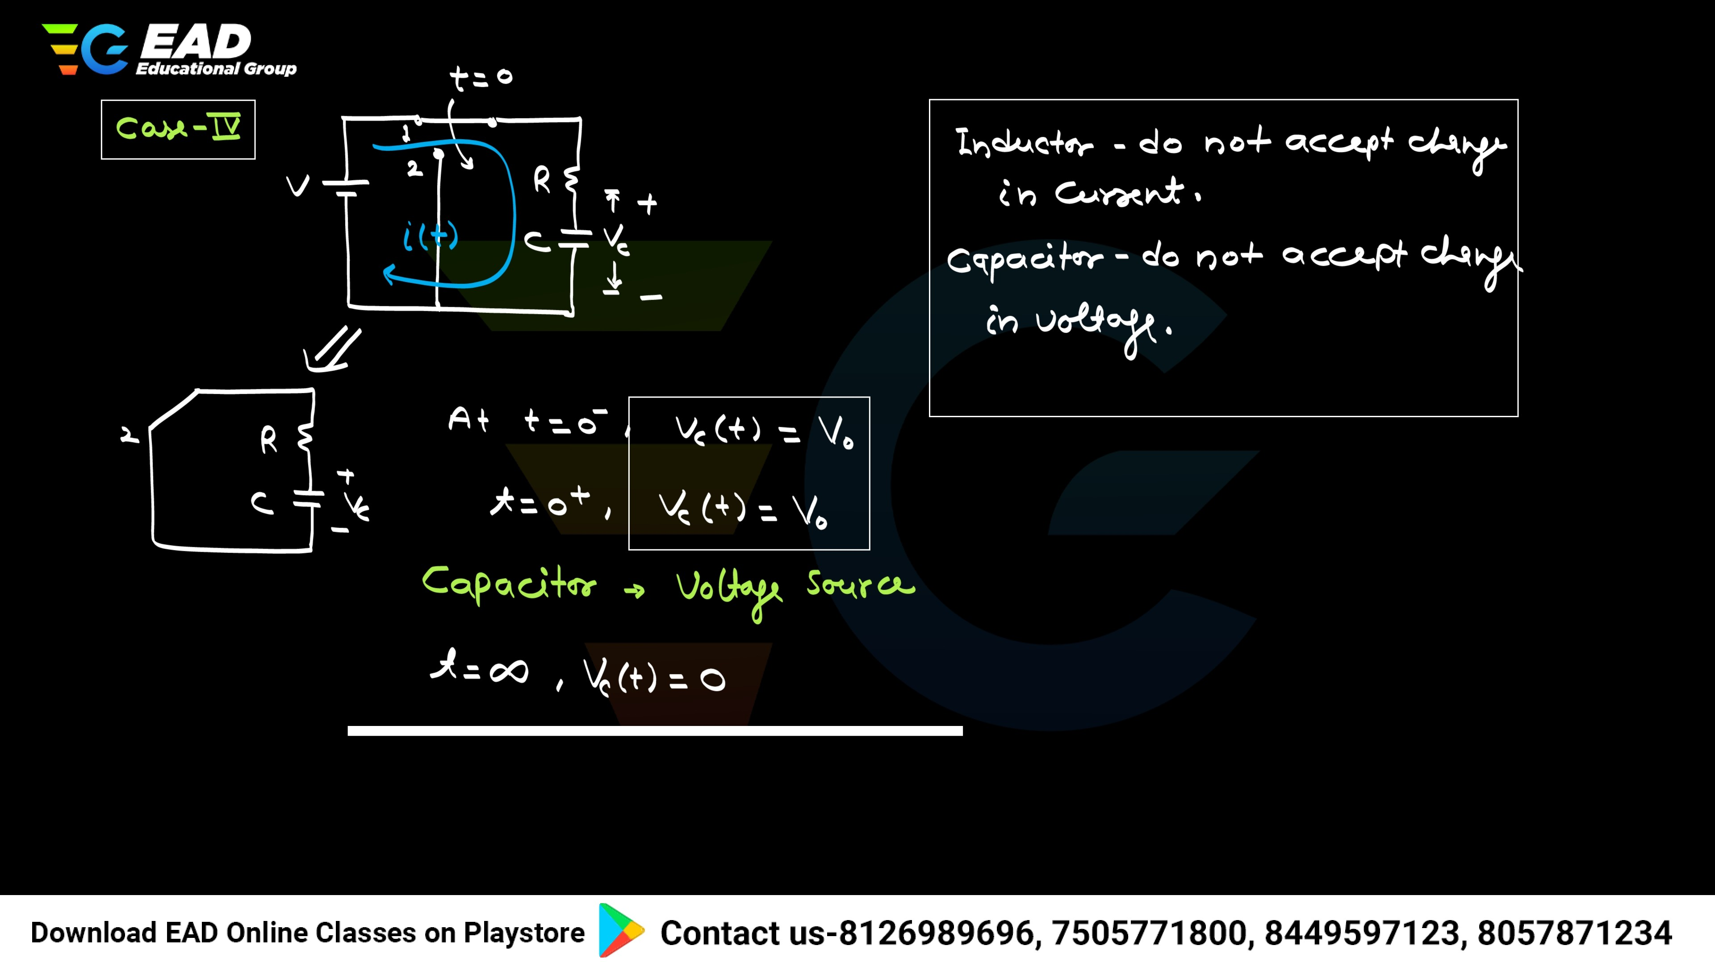

[LAKSHYA BATCH FOR ALL ELECTRICAL ASSISTANT ENGINEERING EXAMS | | Download EAD Online Classes app -> **click here**](https://eadonlineclasses.com/courses/435357?utm_source%3Dother%26utm_medium%3Dtutor-course-referral%26utm_campaign%3Dcourse-overview-webapp)

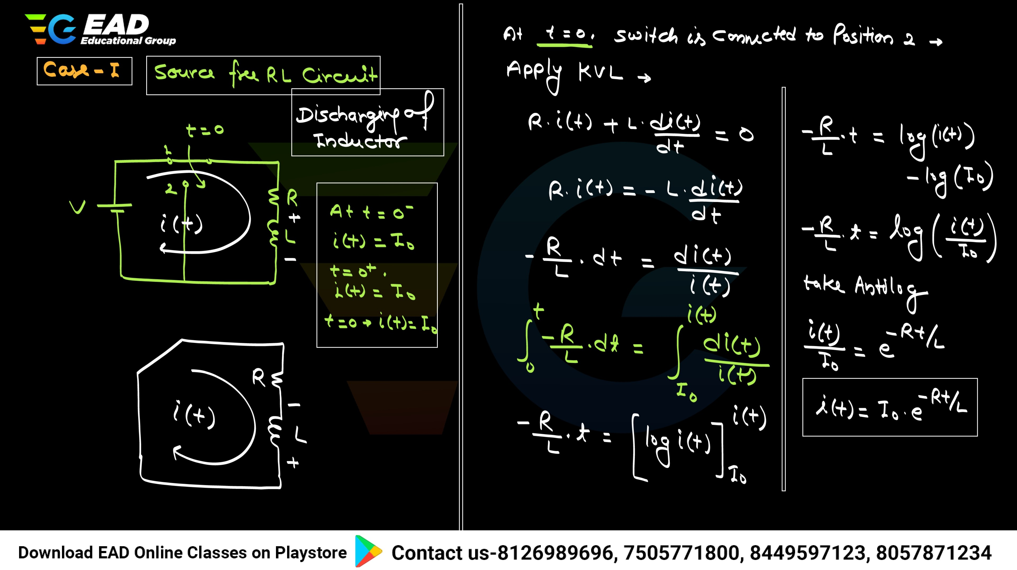

[LAKSHYA BATCH FOR ALL ELECTRICAL ASSISTANT ENGINEERING EXAMS | | Download EAD Online Classes app -> **click here**](https://eadonlineclasses.com/courses/435357?utm_source%3Dother%26utm_medium%3Dtutor-course-referral%26utm_campaign%3Dcourse-overview-webapp)

LAKSHYA BATCH FOR ALL ELECTRICAL ASSISTANT ENGINEERING EXAMS | | Download EAD Online Classes app

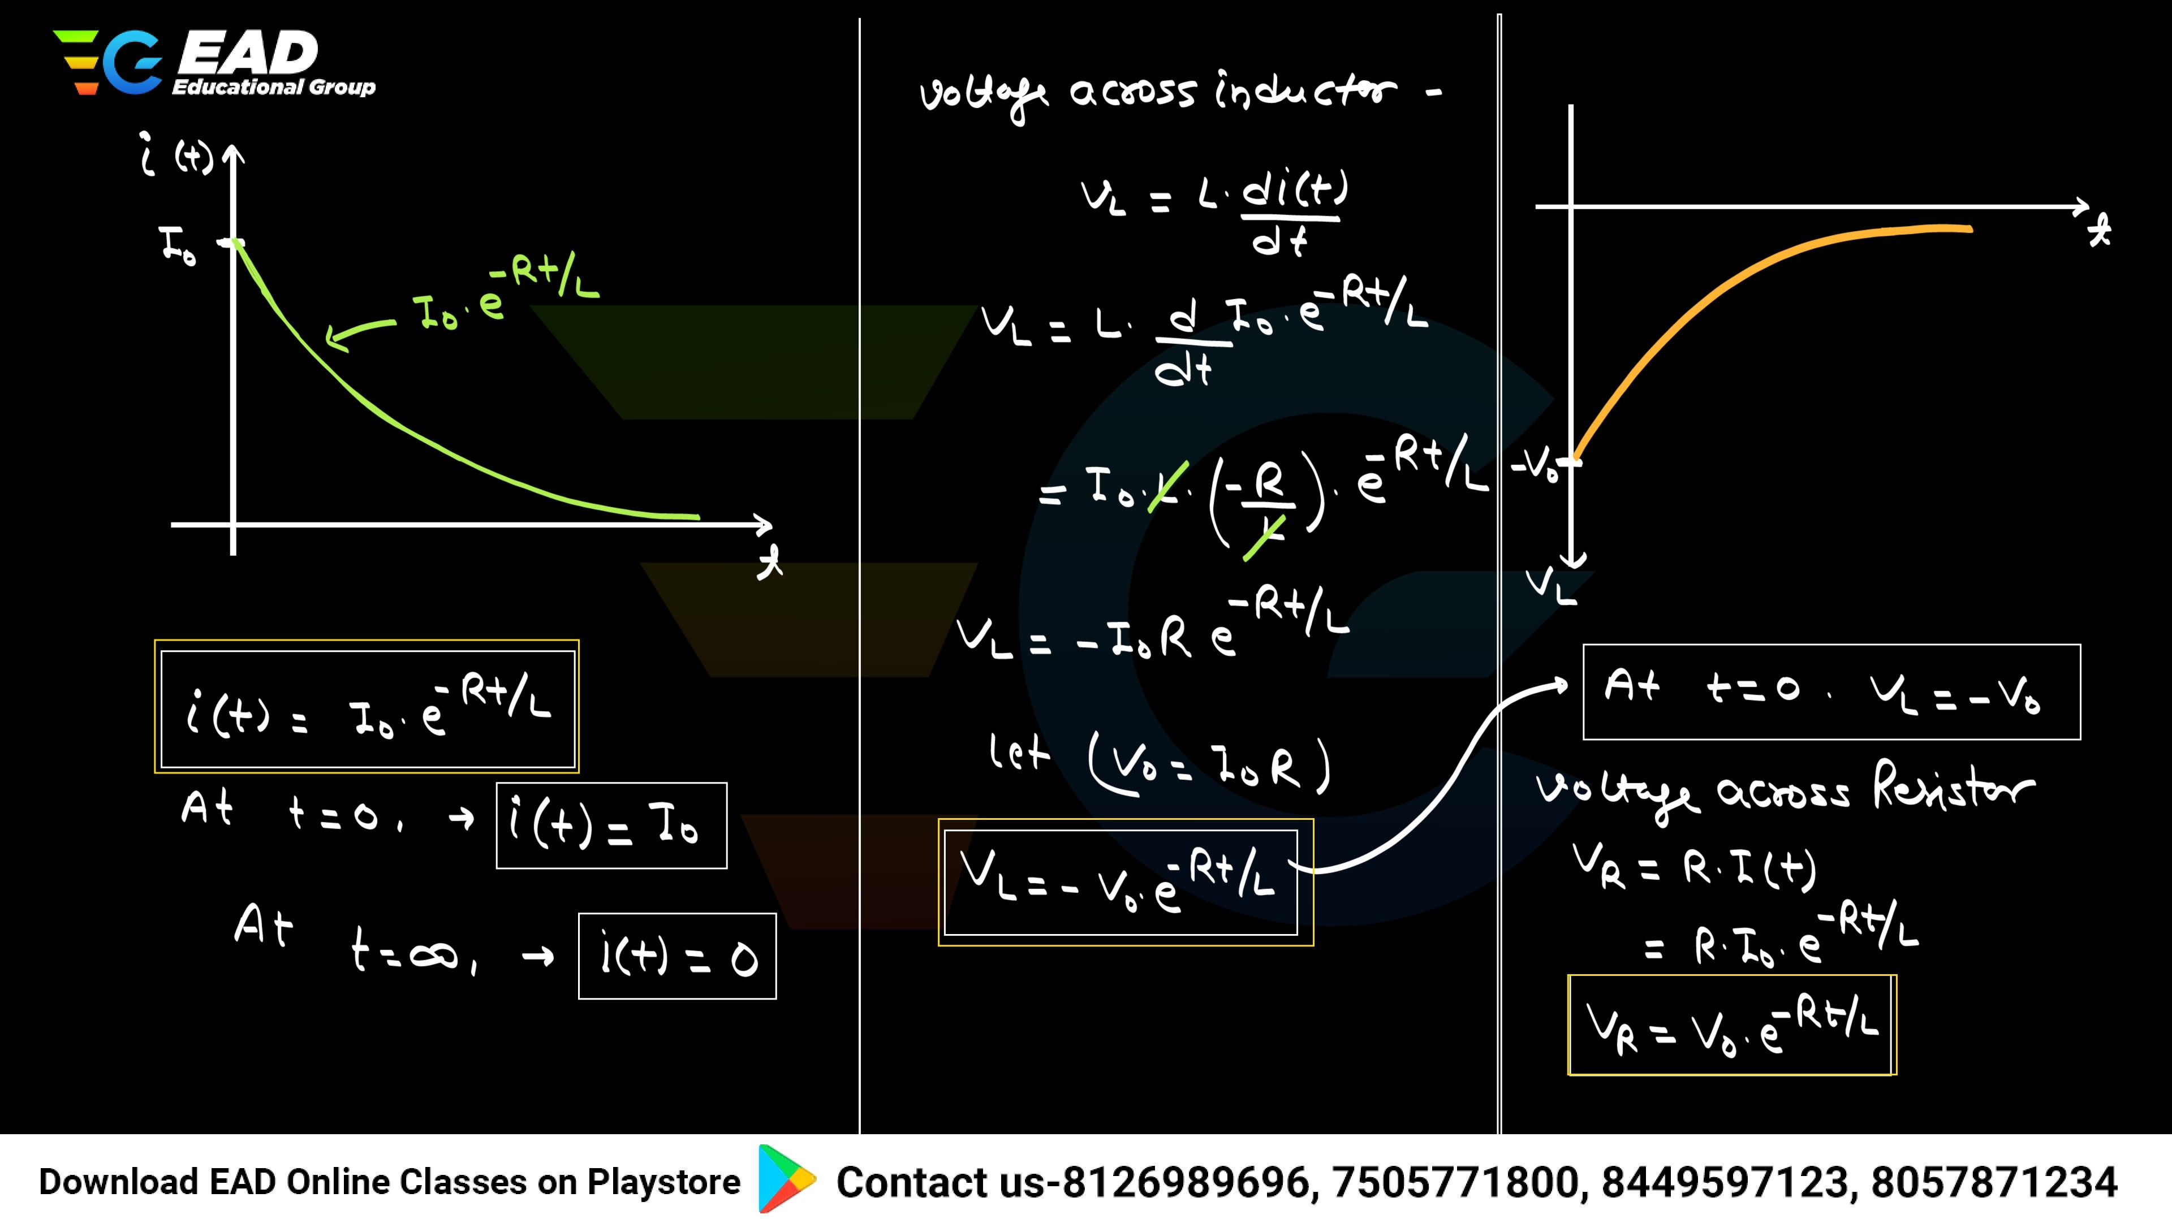

[LAKSHYA BATCH FOR ALL ELECTRICAL ASSISTANT ENGINEERING EXAMS | | Download EAD Online Classes app -> **click here**](https://eadonlineclasses.com/courses/435357?utm_source%3Dother%26utm_medium%3Dtutor-course-referral%26utm_campaign%3Dcourse-overview-webapp)

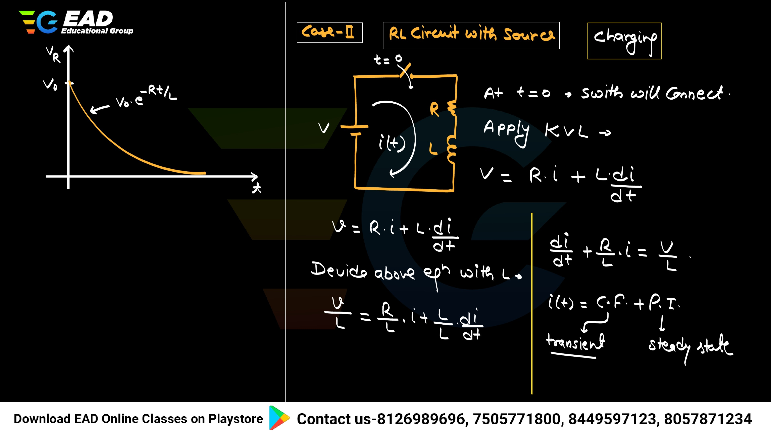

LAKSHYA BATCH FOR ALL ELECTRICAL ASSISTANT ENGINEERING EXAMS | | Download EAD Online Classes app

[LAKSHYA BATCH FOR ALL ELECTRICAL ASSISTANT ENGINEERING EXAMS | | Download EAD Online Classes app -> **click here**](https://eadonlineclasses.com/courses/435357?utm_source%3Dother%26utm_medium%3Dtutor-course-referral%26utm_campaign%3Dcourse-overview-webapp)

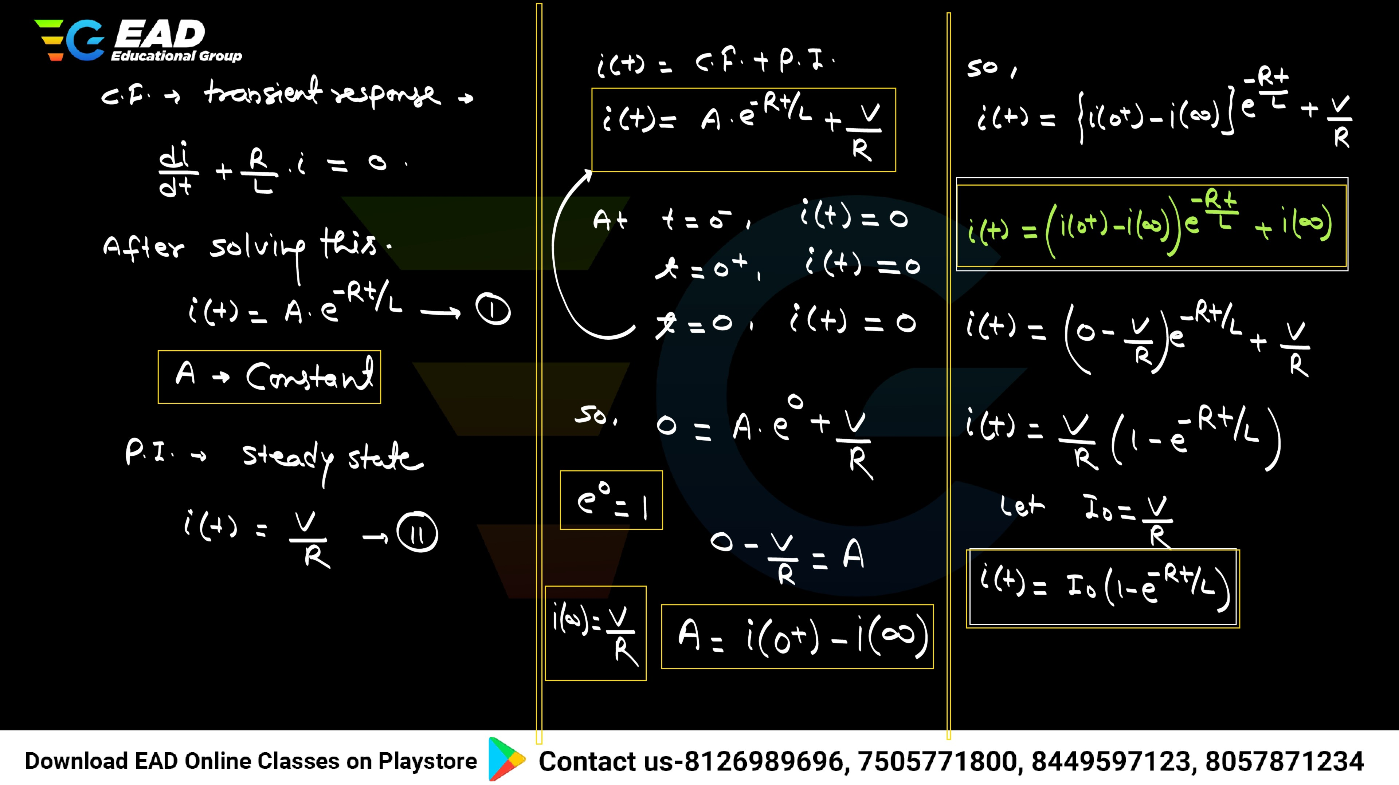

LAKSHYA BATCH FOR ALL ELECTRICAL ASSISTANT ENGINEERING EXAMS | | Download EAD Online Classes app

[LAKSHYA BATCH FOR ALL ELECTRICAL ASSISTANT ENGINEERING EXAMS | | Download EAD Online Classes app -> **click here**](https://eadonlineclasses.com/courses/435357?utm_source%3Dother%26utm_medium%3Dtutor-course-referral%26utm_campaign%3Dcourse-overview-webapp)

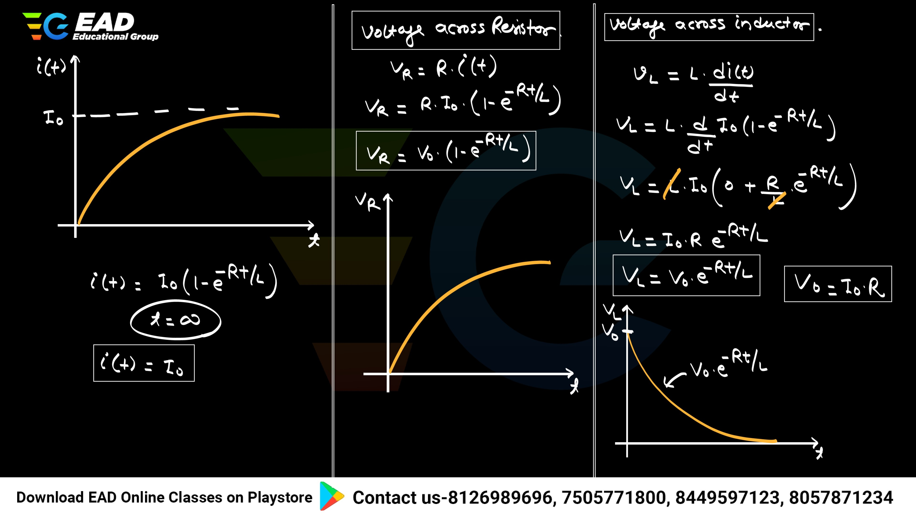

app

[LAKSHYA BATCH FOR ALL ELECTRICAL ASSISTANT ENGINEERING EXAMS | | Download EAD Online Classes app -> **click here**](https://eadonlineclasses.com/courses/435357?utm_source%3Dother%26utm_medium%3Dtutor-course-referral%26utm_campaign%3Dcourse-overview-webapp)